
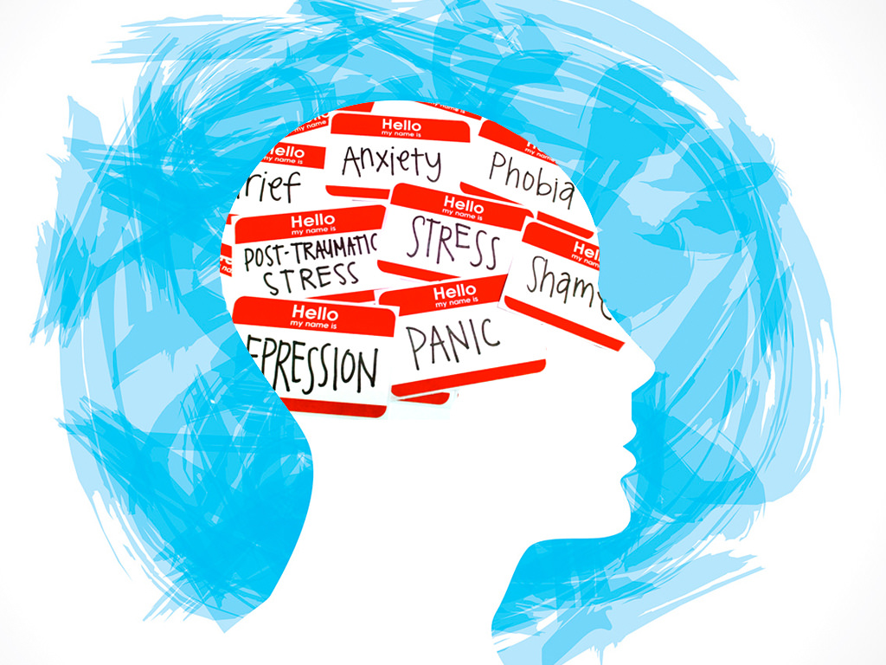
Calling parents and youth in BC!
COVID-19 and Youth Mental Health

Since COVID-19 was declared a pandemic, many public health responses have been implemented including social distancing measures and school closures.

These measures may have an impact on the mental health of children and teens, and we need to adjust the type and amount of resources being offered our children.

The MyHEARTSMAP team needs your help to measure how much and in what ways the changes in our lives during the pandemic have affected the social and psychological wellness of our children and youth.

Using the MyHEARTSMAP online psychosocial self-screening tool, children, youth, and (or) their parents, can learn about which aspects of their mental health may be of concern and might benefit from support resources, and where to find them in BC.


Learning about our children’s needs will help guide our provincial mental health resource planning.

Who can participate in this study?
- Children and youth aged 10-17 in BC
- Parents with a child aged 6-17 in BC

What is involved?
- Answer questions about how COVID-19 has affected you

- Complete the MyHEARTSMAP Self-Screening Tool after enrolling,
and again in 3 months

If you are interested in learning more and participating, please visit our website at:

MyHEARTSMAP-Pandemic.bcchr.ca

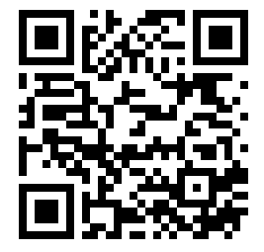

Version 2.0 H20-01658 July 28, 2020 Page 1 of 1

